RAxML Result for Intronic Protein-

Non-Redundant database-

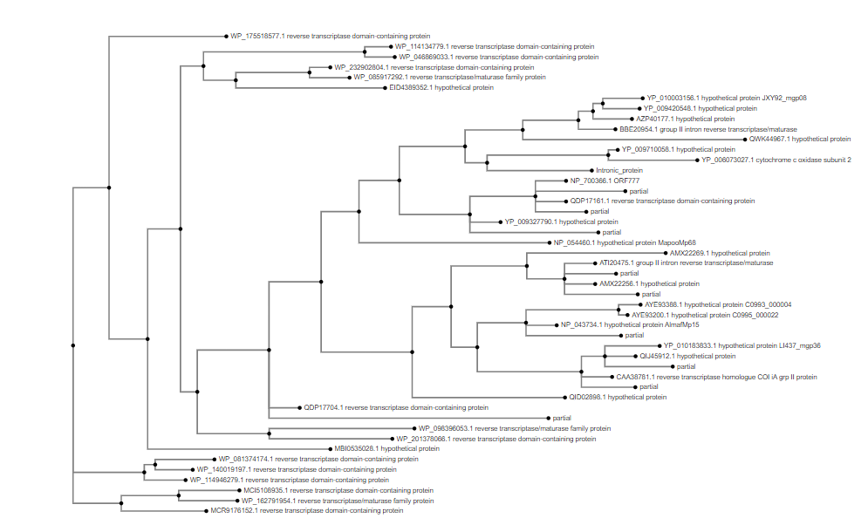

Metagenomic Database-

